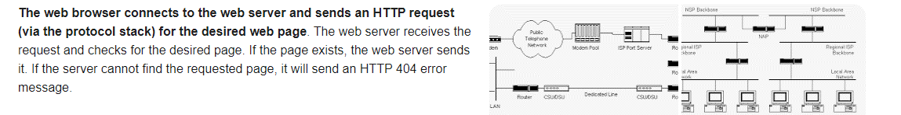

**Steps to Become a Web Developer**

1. Earn Degree(s) An aspiring web developer must first complete an education to develop basic coding and programming skills. ...
2. Pursue Internship(s) Landing a solid internship as a new web developer provides vital work experience. ...
3. Build Your Portfolio. ...
4. Earn Certification(s) ...
5. Create Your Resume.

Web development **gives you the opportunity to express yourself creatively on the internet**. If you have an idea you would like to try as you discover your web dev skills, try it out. Web dev is a fun, creative experience.